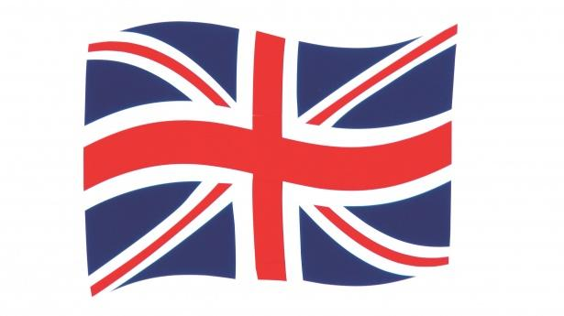

Make it!
The Union Jack flag that you have in this file is made up of food that is farmed or grown in Britain. With an adult, using the pictures provided identify as many of the foods as you can. You can then write down all the different types of foods that you like.

Once you have done this, count how many of these different foods that you have eaten.

Using the Eatwell plate, draw a picture or stick the picture of 5 different types of food into the plate. You can then label the different foods. Discuss with the adult why you have chosen those foods.

