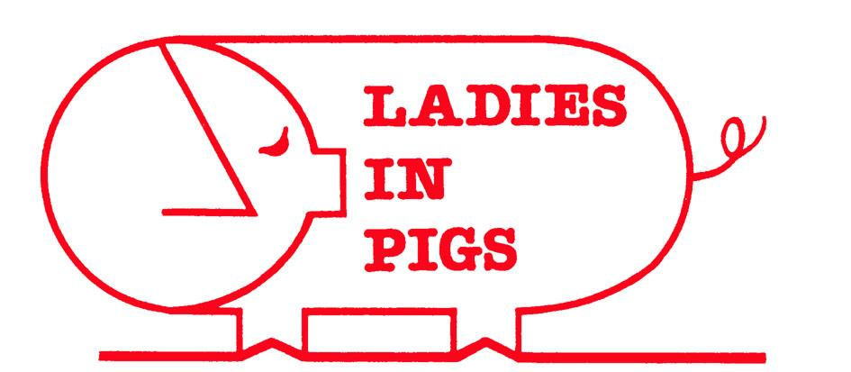
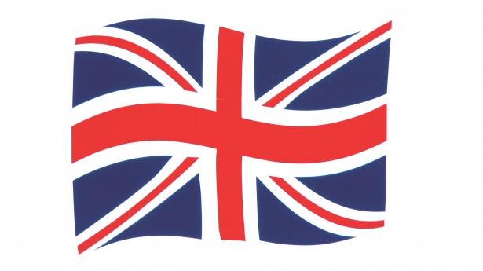
Make it!

The Union Jack flag that you have been shown is made up of food that is farmed or grown in Britain. Using the picture provided, identify as many of the foods as you can. You can then write down all the different types of foods that you like.

Once you have done this, count how many of these different foods that you like. Ask your family or classmates about which foods they like and then draw a bar chart to show the results and how they differ. Send a picture of your bar chart by email to ladiesinpigs@gmail.com

Last job…
Make your own Flag of British produce by looking at the example of the flag and colouring neatly as you can!

